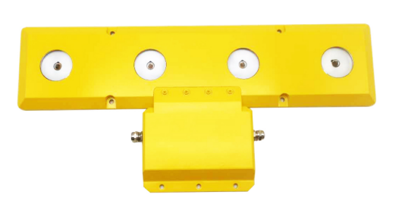
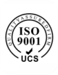 | 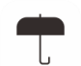  IP68 | 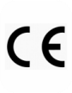 | 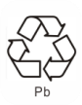 | 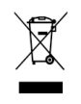

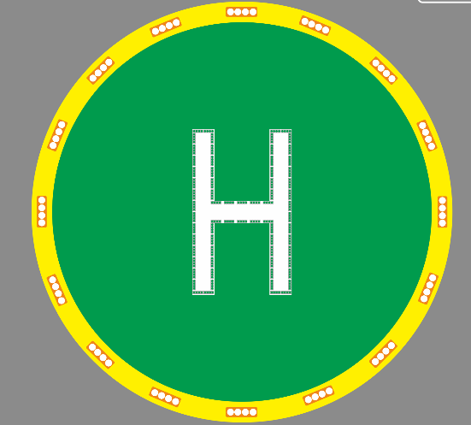

APPLICATION
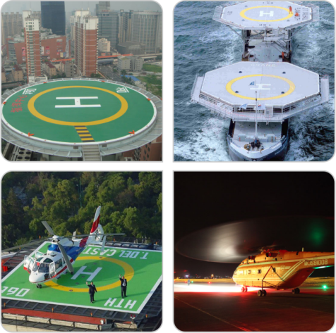
Helideck Circle-H Light
AH-HP-H
Heliport Marking light is for the heliport identification marking “H” and the circle, The design of thickness (＜25MM ) make it easily installed and suitable for all kinds of heliport.

Compliance
- ICAO Annex 14 Volume I ,Appendix I Nov. 2016, figure A1-1-Colors for aeronautical Ground lights

Features
Electrical
- LED as light source saving power consumption and maintenance, 95% less power than equivalent incandescent light
- Power supply available in AC(110-240VAC), DC48V
Physical
- Unique designed polycarbonate lens for converging light and also provides corrosion resistance and UV protection.
- integrated cable connection
- UV protection Powder coated bright yellow color base make better visibility
- Base material is die casting aluminum which has strong corrosion resistance, Shock and Vibrations protection
- Customized cables with vulcanized cable termination protection and captive connection screws;
- Fault monitoring with fail indication via controller
Optional
- Infrared LED for pilot using NVG(Night Vision Goggles)
- Controller for power supplying and turn ON/OFF light
- VHF pilot to ground remote control
- Marine treated

Application
- Helipad/Heliport
- Drilling rigs
- Platforms

Dimension

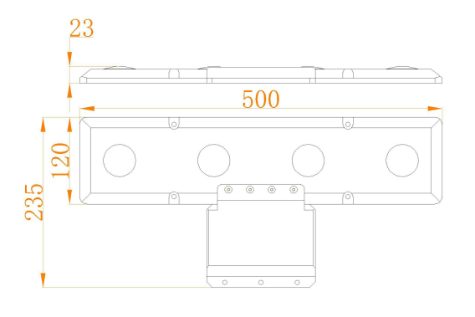

Installation

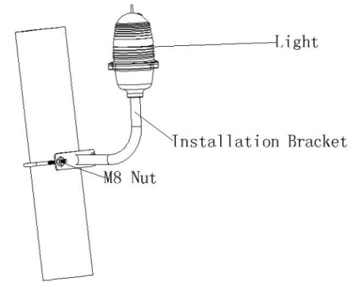

Helideck Circle-H Light
AH-HP-H

SPECIFICATIONS | AH-HP-H Helideck Circle-H Light
Light Characteristics
Light Source | LED
Available Colors | Green, Yellow (others are optional)
Effective Intensity(cd) | 2-12° ≤60cd
 | 12-20°≤30cd
 | 20-90°≤10cd
Flash Characteristics | Steady burning
Operation Mode | 24hours operation
LED Life Experience(hours) | >100,000
Electrical Characteristics
Operating Voltage | DC(12-48VDC) or AC(110-240VAC)
Power(W) | 3
Circuit Protection | Integrated
Physical Characteristics
Body Material | UV protected Polycarbonate
Base Material | Powder-coated Die-casting aluminum
Dimension(mm) | 235×500×23
Weight(kg) | 3.83
Product Life Expectancy | Average 5 years
Environmental Factors
Ambient Temperature(℃)  -55℃~+70℃ | -25~70
Humidity | 10~90%
Wind Speed | 80m/s
Waterproof | IP68
Compliance
ICAO | ICAO Annex 14 Volume I ,Appendix I
 | Nov. 2016, figure A1-1-Colors for aeronautical
 | ground lights

Heliport Lighting on roof of building

